

Submitted by:
Name: Istiak Alam
ID: 05
Batch: 20
Lab report: 10
Date: 4.12.22
Course: CSE LAB
Course Code: 1202
Lab task Topic: Structured Programming Problems Solve {User define function}

Submitted to:
Nafisa Tabassum

LECTURER, NDUB

Problem No. 01
Name of the problem:
Write a program in C to find the square of any number using the function
Introduction
Implementing program in C is very interesting. To implement the problem given above we should remember the procedure to display outcome. That is, we should consider about the required inputs, the particular process that will be applied upon the input data and the output whether it is desired or not. The given problem gives me an opportunity to have an exercise on the procedure.

Program:
//determine square value by user define function
#include <stdio.h>
int main()
{
int a, result;
printf("Going to calculate the square value\n");
printf("Input any number of square:");
scanf("%d",&a);
result=sum(a);
printf("The square of %d is:%d",a,result);
}

int sum(int a)
{
return (a*a);

}

Output:
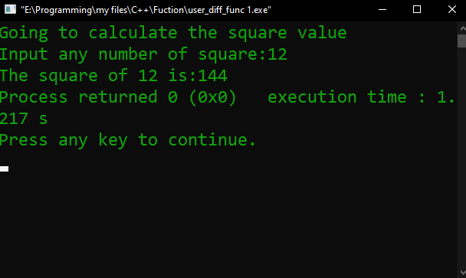

Problem No. 02
Name of the problem:
Write a program in C to swap two numbers using a function
Introduction
Implementing program in C is very interesting. To implement the problem given above we should remember the procedure to display outcome. That is, we should consider about the required inputs, the particular process that will be applied upon the input data and the output whether it is desired or not. The given problem gives me an opportunity to have an exercise on the procedure.

Program:
//swiping value by user define function
#include <stdio.h>
int main()
{
int a,b,c,d,e;
printf("Enter the value of A=");
scanf("%d",&a);
printf("enter the value of B=");
scanf("%d",&b);
printf("Before swapping: A =%d , B =%d\n",a,b);

swipe();
d=swipe(a);
e=swipe(b);

printf("After swapping: A=%d , B=%d", d,e);
}

int swipe(int a,int b,int c)
{
c=a;
a=b;
b=c;

return(a,b);
}
Output:
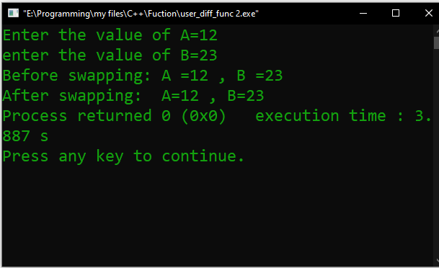

Problem No. 03
Name of the problem:
Write a program in C to check a given number is even or odd using the function
Introduction
Implementing program in C is very interesting. To implement the problem given above we should remember the procedure to display outcome. That is, we should consider about the required inputs, the particular process that will be applied upon the input data and the output whether it is desired or not. The given problem gives me an opportunity to have an exercise on the procedure.

Program:
//Even Odd (user define function)
#include <stdio.h>
int main()
{
int a;
printf("Enter any number: ");
printf("");
scanf("%d",&a);

if(a%2==0)
even();
else
odd();
}
even(int a)
{
printf("The entered number is Even.");
}
odd(int a)
{
printf("The entered number is Odd.");
}
Output:
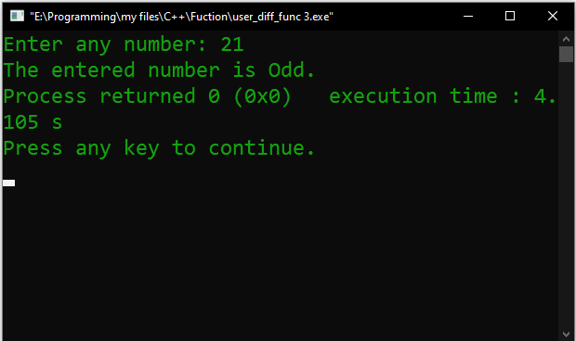

Problem No. 04
Name of the problem:
Write a program in C to get the largest element of an array using the function.
Introduction
Implementing program in C is very interesting. To implement the problem given above we should remember the procedure to display outcome. That is, we should consider about the required inputs, the particular process that will be applied upon the input data and the output whether it is desired or not. The given problem gives me an opportunity to have an exercise on the procedure.

Program:
//find Maximum value from array numbers user define function
#include <stdio.h>
int main()
{
int a[1000],i,n,sum;
printf("Enter size of the array : ");
scanf("%d", &n);
printf("Enter elements in array : ");
for(i=0; i<n; i++)
{
scanf("%d",&a[i]);
}
sumofarray(a,n);
}
int sumofarray(int a[],int n)
{
int min,max,i;
min=max=a[0];
for(i=1; i<n; i++)
{
if(min>a[i])
min=a[i];
if(max<a[i])
max=a[i];
}
printf("minimum of array is : %d",min);
printf("\nmaximum of array is : %d",max);
}
Output:
